**BRAINSTORM & PRIORITIZE IDEAS**

**--------------------------------------------------------------------------------------------**

|  |  |
| --- | --- |
| NAME | T.SURESH KUMAR |
| NM ID | EA32343CFBC1AD09D4E465F983490A2F |
| PROJECT | HOW TO CREATE A GOOGLE ADS COMPAIGN FOR YOUR BRAND |

**BRAINSTORMING AND IDEA PRIORIZATION :**

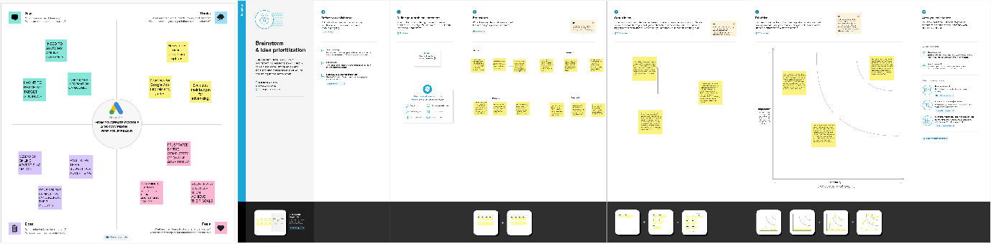

**BRAINSTORMING AND IDEA PRIORIZATION LINK :**

<https://app.mural.co/t/suresh8378/m/suresh8378/1698856033880/24cfa6386b8102a747ea231f7f6b0db4e9520d98?sender=u30a67f9b441b4e205e280708>